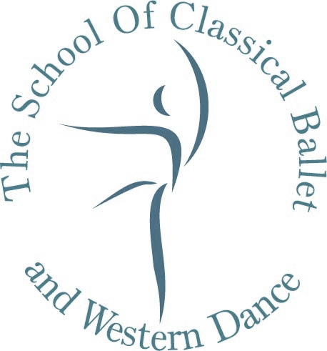
The School of Classical Ballet and Western Dance
412, A Wing, 4th floor, Panchshil Plaza, Near Dharam Palace, Gamdevi Road, Mumbai 400007.
Tel: 23620026/ 27 Mobile: 9920253172 info@balletindia.com www.balletindia.com

AUDITION WORKSHOP FORM

(PLEASE FILL IN BLOCK LETTERS)

PUPIL’S NAME ______________________________________________

WILL PARTICIPATE IN THE AUDITION WORKSHOP. I/WE WILL ATTEND THE PARENTS MEETING ON SATURDAY 17th NOVEMBER 2018 AT 11 AM AND SUBMIT THE AUDITION FEE OF Rs. 3,500/- (Cash only)

SCHOOL ATTENDED: _________________________________________

SCHOOL TIMINGS:____________________ to______________________

DATE OF BIRTH: ______________________________________________

AGE (NOVEMBER 2018) _______________Yrs._________________Mths

DANCE CLASSES ATTENDED (IF ANY)__________________________

DURATION OF DANCE CLASSES ATTENDED ______Yrs.______Mths
(Please scan us a copy of the result form in case appeared for any examinations on info@balletindia.com)

DATE: ______________________________________________________

SIGNATURE OF PARENT: ______________________________________

Telephone Numbers :(R)___________________________ (O)______________________

Mobile Number: __________________________________________________________

E mail Address: __________________________________________________________

Referred by: ___________________________________________________________

Tushna F. Dallas, FISTD ARAD (London)
Director

Khooshoo Dallas, LRAD, ARAD, LISTD (London)
Co-Director

